Bill Managment instructions – How to upload and code an invoice?
Use only Chrome as your browser go to www.bill.com
Email – You company email
Password – enter your bill.com password
Click on Sign in

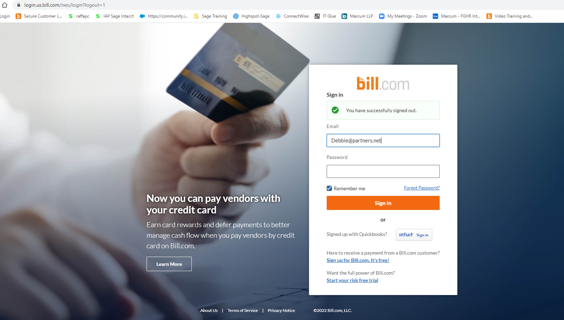
Click on Partners of the Americas, Inc

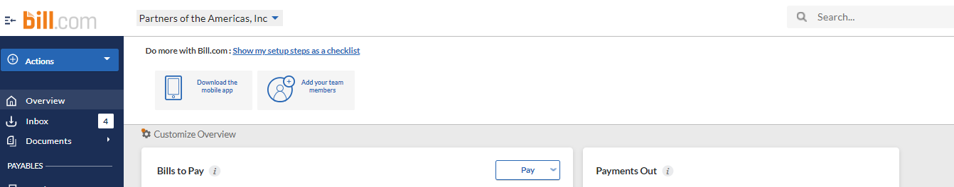

Click on Inbox on the left blue bar

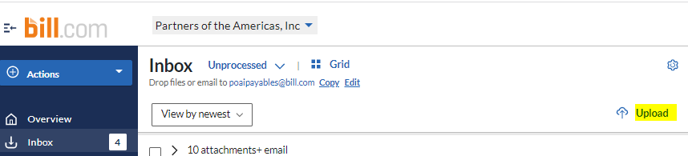
Click on Upload as highlighted to the left and select the file from your computer that needs to be uploaded. All files need to be in one pdf document file to be uploaded. The file should include a summary cover page with all backup bills and supporting documentation attached behind it.
Click open
File should show up in the inbox and with a min your uploaded bills should be ready to be processed.

Click Enter bill. On the top right as shown below

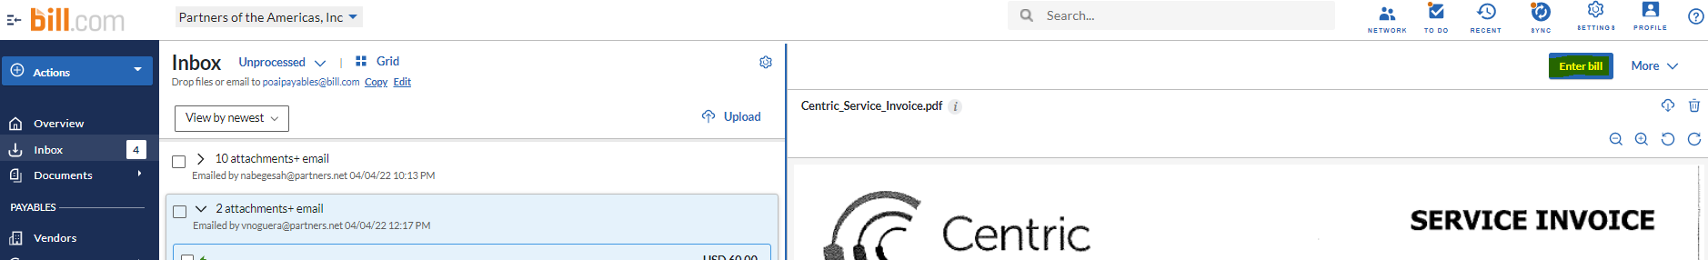

Once you are on the enter bill screen, please verify the vendor, invoice number, amount, date and due date and other * marked fields as they are required fields to process the bill.

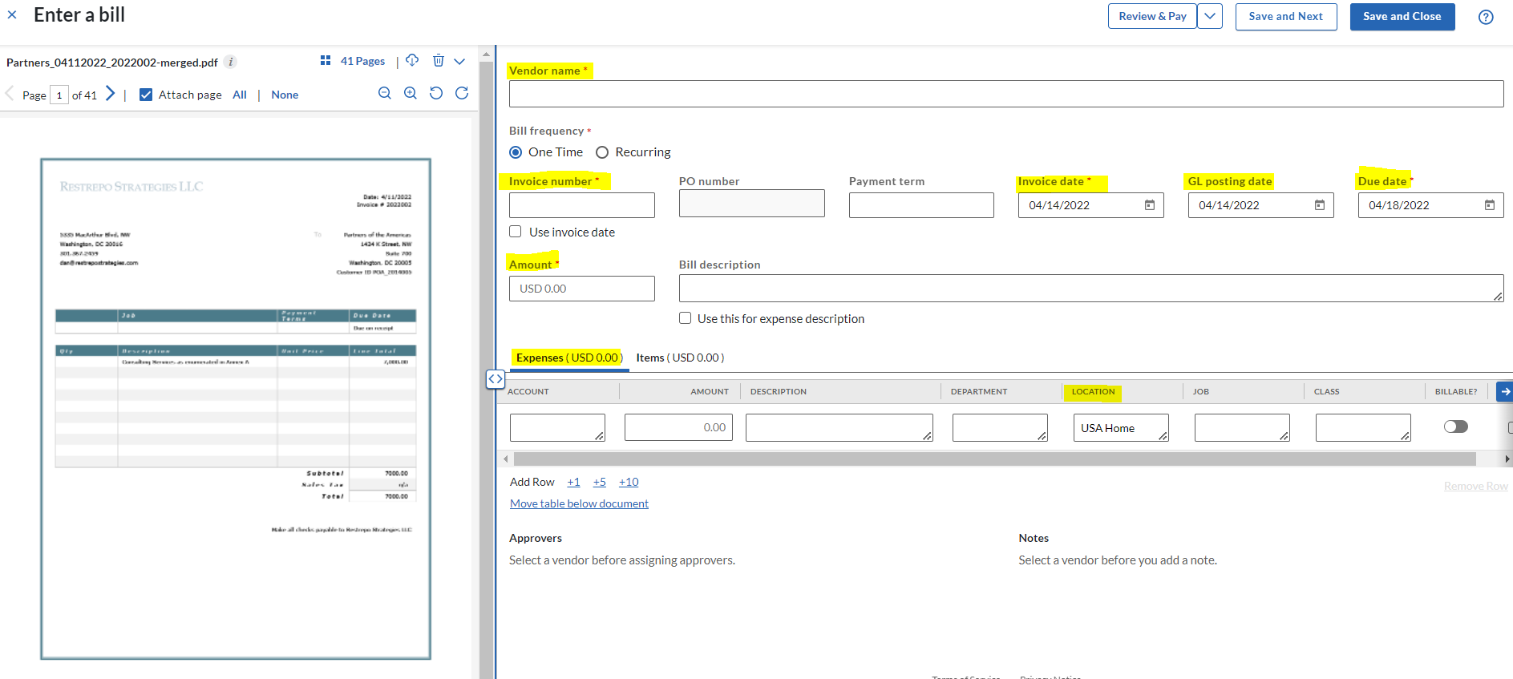

Next step would be to fully code the bill with all the details of the expense

Click on the Items tab

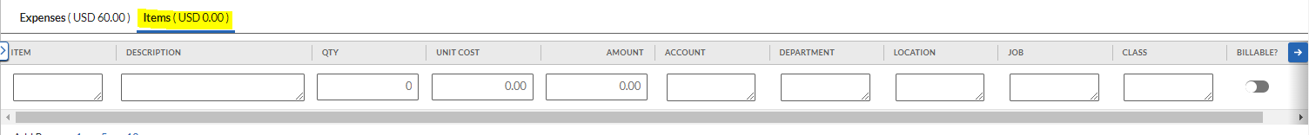
Use Items are (the Budget) codes only if applicable
Description – purpose of the expense using appropriate abbreviations
Qty & Unit cost- can be skipped only.
Total amount of the invoice in the Amount field if there is only one line for the expense.
If the expense is coded in several lines, the total of all the amounts should equal the invoice total.

Account – Please select the account name which best fits the expense in relation to the budget code.
Examples – 82401 Supplies, 87000 Training & Workshops
Department - Please select the appropriate department from the dropdown list.
Example - 10192 Resource Development (92RD – Business development) or
10220 Operational (95O – Operations)
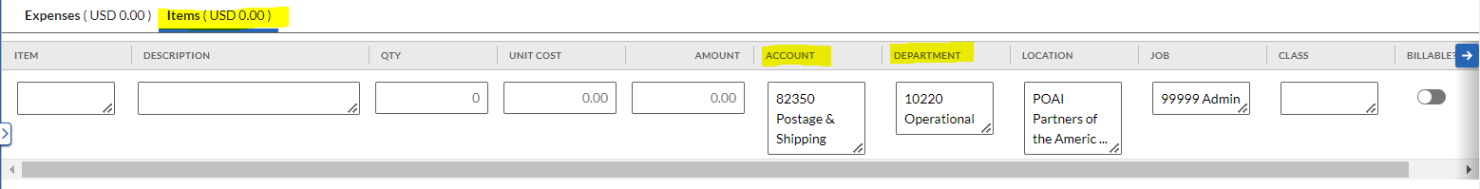

In the Items tab please select the location as specific as possible and select the right Location under it.
For example Home office would be USA Home office or select the country code abbreviation like MEX Mexico or any other applicable location relating to the expense.
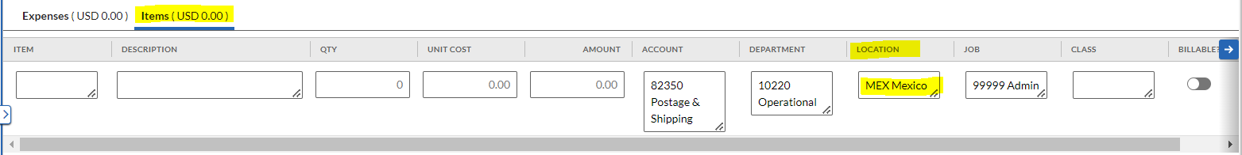
Jobs/Programs/Award – Select the appropriate award from the dropdown. If the award is not shown in the list please reach out to Finance team to get the list updated.
Example - USAID800 Juntos Aprende or for admin expenses or non-program expenses - 99999 Admin
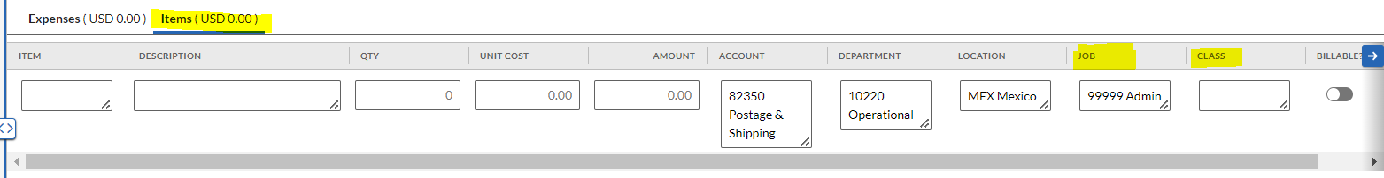
Class- Do not use class field for any expense coding. LEAVE BLANK
Billable – Do not use this field. Not applicable to expenses coding.
In the Approvers section – In the 3rd available approver assignment box- type the first name of your supervisor approver and drag the name to be the first approver.
As shown below Debbie was added to the approval workflow at the bottom and move up as the first approver for the bill to be presented to the finance team for approval.
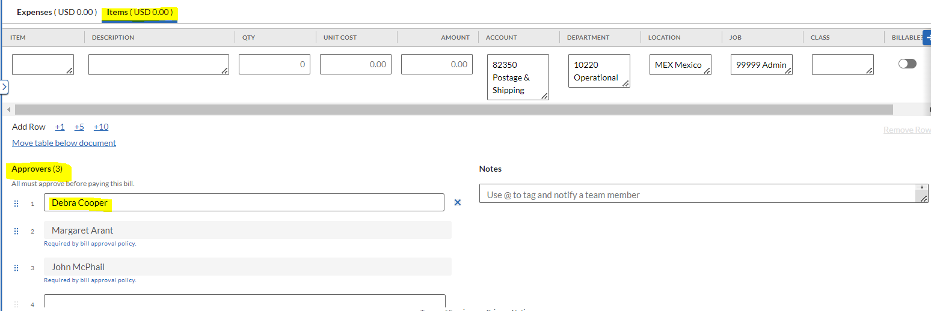

Notes – Additional review option for team members who are not involved in the approval workflow.
You can add anyone who needs to look at your coding of the expenses by using the notes section highlighted below.
You can use @ First name and then type the message for the collaborator to get the message. This will initiate an email to the collaborator to click on the link and look at the bill and reply back in case of any changes needed.
